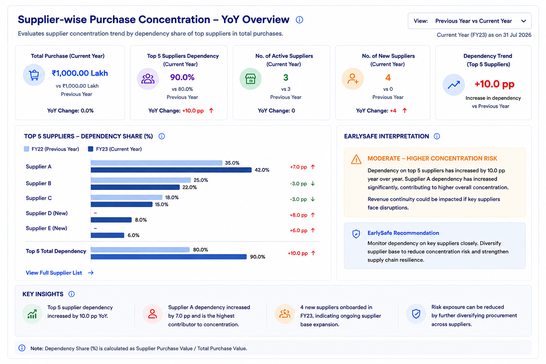
Supplier concentration

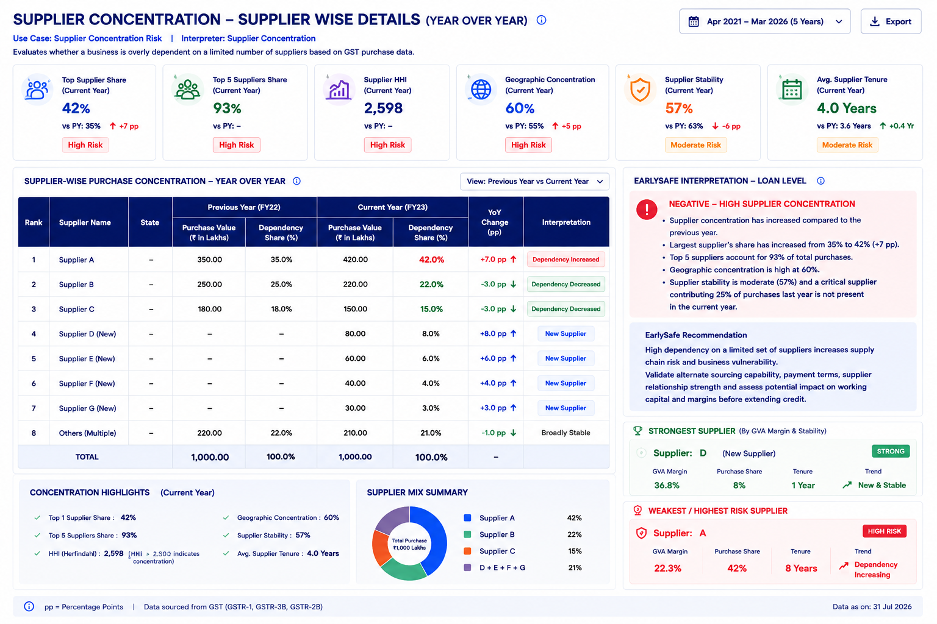

Supplier Concentration

1. Purpose
The Supplier Concentration analysis evaluates how dependent a company is on its suppliers and whether its purchase base is becoming more concentrated or more diversified over time.
The analysis is performed at the company/PAN level by consolidating purchase transactions across all GSTINs mapped to the company. The objective is to identify:
- The company's major suppliers
- The share of total purchases coming from each supplier
- Whether dependency on major suppliers is increasing or decreasing
- New suppliers entering the purchase base
- Suppliers that have attrited/left
- The overall stability of the supplier base
The analysis uses GSTR-2B supplier/invoice-level data.

2. First View — Supplier Concentration Chart
The first view provides a summary of the company's Top 5 suppliers based on their purchase dependency share.
The chart compares:
- Previous Period Dependency Share
- Current Period Dependency Share
- Movement in Dependency
This allows the user to quickly understand whether the company's purchases are becoming more dependent on a limited number of suppliers.

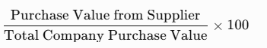
Supplier Dependency Share Per Supplier formula
Supplier Dependency Share (%) =
A higher dependency share means that a larger proportion of the company's purchases comes from that supplier.
The Top 5 suppliers are ranked based on their dependency share in the current comparison period.

3. Comparison Period
The comparison period changes based on the time period selected by the user.

If Past 1 Year is selected
The one-year period is divided into two equal six-month periods:
- Previous Half-Year
- Current Half-Year
The analysis compares supplier activity between these two periods.

If Past 2 Years or more is selected
The comparison is performed on an annual basis, using comparable 12-month periods.
The same comparison framework is used for:
- Supplier dependency
- New suppliers
- Supplier attrition
- Purchase concentration movement

4. Second View — Supplier-Wise Tabular Analysis
When the user clicks on the chart, a detailed supplier-level table opens.
The table can display:
Parameter | Description
Supplier Rank | Rank based on current-period dependency share
Supplier Name | Name of the supplier
Previous Period Purchase Value | Purchase value during the previous comparison period
Previous Period Dependency Share | Supplier's share of total company purchases
Current Period Purchase Value | Purchase value during the current comparison period
Current Period Dependency Share | Supplier's current share of total company purchases
Dependency Change | Change in supplier dependency between the two periods
Supplier Status | Existing, New Supplier or Supplier Left
Interpretation | Summary of the supplier's movement

5. Supplier Purchase Value
Supplier purchase value represents the total taxable value of purchases attributable to a particular supplier during the selected period.

Formula
Purchases from the same supplier should be consolidated across all company GSTINs
Data source GST-2B.
The supplier should preferably be identified using the Supplier GSTIN, while the supplier name can be used for display.

6. Total Company Purchase Value
Total company purchase value represents the combined purchase value from all suppliers during the selected period.

Formula
Total Company Purchase Value = ∑Purchase Value across all Suppliers

Data source- GST2B
This value is calculated separately for each comparison period and is used as the denominator for dependency calculations.

7. Supplier Dependency Share
Supplier dependency share measures the supplier's contribution to the company's total purchases.

Formula
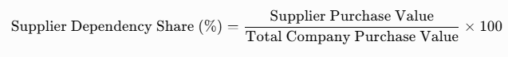
The calculation is performed separately for the previous and current comparison periods.

8. Dependency Movement
The change in dependency should be calculated in percentage points (pp).

Formula

Dependency Change (pp) = Current Period Dependency Share−Previous Period Dependency Share / Previous Period Dependency Share

Interpretation
- Positive change → Dependency Increased
- Negative change → Dependency Decreased
- Minimal change → Dependency Broadly Stable
The analysis should focus on the movement in the supplier's share of total purchases, rather than only the increase or decrease in absolute purchase value.

9. New Supplier
A supplier is identified as a New Supplier when the supplier has purchase activity in the current comparison period but had no purchase activity in the previous comparison period.
Yes. For New Supplier identification, we can first measure the change in total supplier count, and if the supplier count has increased, then identify the newly added supplier names and calculate the new supplier rate.

1. Active Supplier Count
For each comparison period:
Active Supplier Count = Count of Unique Supplier GSTINs with Purchase Value>0
Calculate separately for:
- Previous Period Active Supplier Count
- Current Period Active Supplier Count

2. Supplier Count Change

Formula
Supplier Count Change = Current Period Active Supplier Count−Previous Period Active Supplier Count x

Interpretation
- Positive value → Overall supplier base has increased.
- Negative value → Overall supplier base has decreased.
- Zero → No net change in supplier count.

3. New Supplier Identification
When the supplier count has increased, identify suppliers that are present in the current period but were not present in the previous period.

Formula
New Suppliers=Current Period Supplier Set−Previous Period Supplier Set
The output will provide the:
- New Supplier Name
- New Supplier GSTIN
- Current Period Purchase Value

4. New Supplier Count
New Supplier Count=Count of Unique Suppliers present in Current Period but not in Previous Period

5. New Supplier Rate (%)
The new supplier rate measures the number of new suppliers added relative to the previous supplier base.

Formula
This shows the extent to which the company's supplier base has expanded.

10. Supplier Attrition
Supplier attrition measures suppliers that were active during the previous comparison period but have no purchase activity during the current comparison period.

Supplier Attrition Counts
- Supplier count of previous > supplier count of current then the supplier the organsiation left
- Supplier count of previous < supplier count of current then the supplier the organsiation joined
- Supplier count of previous = supplier count of current then the supplier the organsiation sustain for the year

If supplier leave the organization then identify the rate :

Supplier Attrition Rate
This shows the percentage of previously active suppliers that are no longer contributing to the company's purchase activity.

11. Supplier Attrition Value
Supplier attrition should also be assessed based on the value of purchases associated with suppliers who left, as supplier count alone does not indicate the materiality of the change.

Formula

Supplier Attrition Value=∑Previous Period Purchase Value of Attrited Suppliers

Attrition Value Share

100
This identifies how much of the company's previous purchase base was associated with suppliers who have subsequently left.

12. Overall Supplier Concentration
The analysis can also assess how concentrated the company's purchase base is among its largest suppliers.

Top 5 Supplier Concentration
A higher Top 5 concentration means that a larger proportion of the company's purchases is dependent on a limited number of suppliers.

10. Overall Supplier Concentration
The analysis should not only look at individual suppliers but also identify concentration among the largest suppliers.

Top 5 Supplier Concentration
Top 5 Supplier Concentration (%) =
Purchase Value of Top 5 Suppliers ÷ Total Company Purchase Value × 100
This indicates how much of the company's purchasing is dependent on its five largest suppliers.

Interpretation
- Lower Top 5 concentration → more diversified supplier base.
- Higher Top 5 concentration → greater dependence on a limited supplier group.
- Increasing Top 5 concentration → supplier dependency is becoming more concentrated.
- Declining Top 5 concentration → supplier base is becoming more diversified.

13. EarlySafe Interpretation
The interpretation should assess the overall supplier dependency pattern and its movement over time.

Positive Signals
- Dependency on major suppliers has reduced.
- Purchases are becoming more diversified.
- The supplier base remains stable.
- New suppliers have been added without excessive dependency.
- Supplier attrition is low and limited to a small share of previous purchase value.

Points of Attention
- Dependency on a major supplier has increased significantly.
- A large proportion of purchases is concentrated among a few suppliers.
- A new supplier has quickly become a major purchase source.
- Supplier attrition has increased.
- A supplier contributing a significant share of previous purchases has left.

Risk / Impact
High supplier concentration can create:
- Supply-chain dependency
- Business continuity risk
- Procurement disruption risk
- Reduced supplier diversification
- Potential working-capital and pricing pressure
The risk becomes more significant when the company has high dependency on a limited number of suppliers and this dependency continues to increase, or when a major supplier exits the purchase base.

EarlySafe Recommendation
Monitor suppliers with increasing dependency, assess the impact of major supplier attrition, validate alternative sourcing capability, and review material shifts in the supplier base to identify potential supply-chain or business-continuity risk.

Rest will be same for the loan level

